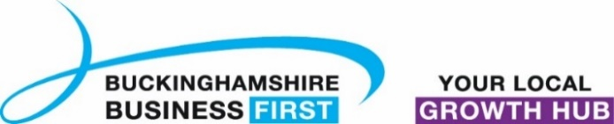
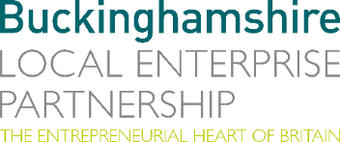
No. 004.24 23 January 2024
N E W S R E L E A S E

Survey highlights challenges for Buckinghamshire businesses
for the year ahead

Buckinghamshire Local Enterprise Partnership and Buckinghamshire Business First’s latest Business Barometer survey shows the second half of 2023 brought slightly weakened business confidence, as rising costs and reduced consumer spending continue to take their toll.

Net balance performance scores suggest trading conditions have not improved since the first quarter of 2023, but are a slight improvement on the previous year. Businesses reported rising sales and custom, turnover and workforce growth, but reported declining orders/ pipeline and rising costs, which is ultimately leading to falling profits.

The Barometer also asked Buckinghamshire businesses for their reactions to the Government’s Autumn Statement, a key bellwether for plans to boost economic growth in the run up to the general election.

Respondents anticipate that the greatest impacts from the Autumn Statement to their business will primarily be from the increase to the National Minimum Wage and increased corporation tax, believing it will reduce competitiveness in export markets and reduced staff numbers. The reduction in National Insurance payments for self-employed was welcomed, however many respondents felt there was an overall lack of support for small businesses.

A range of challenges are also expected to be encountered by businesses in Buckinghamshire over the coming year. The most commonly cited challenges by
more…
Survey highlights challenges for Buckinghamshire businesses: 2

respondents were staff recruitment and retention; skills shortages; dealing with rising costs and maintaining cash flow; and attracting new customers while retaining the existing customer base, with added reference to managing client demands on limited budgets.

This comes against a backdrop of reduced customer demand linked to the cost-of-living crisis, and an increasingly competitive market bringing additional issues concerning the ability for respondents to market their goods and services effectively when budgets are constrained.

Philippa Batting, Managing Director, Buckinghamshire Business First, said: “Escalating costs, challenges with the logistics of getting goods in and out of the UK because of unrest elsewhere in the world and the raising of the minimum wage are all significantly impacting on the cost of being in business for many. Businesses currently working with the Buckinghamshire Business First team are looking for new ideas to support their growth to ensure they are able to navigate these difficult trading conditions.”

Representing almost 50% of the county’s businesses, and more than 70% of the county’s private sector employees, Buckinghamshire Business First provides its 15,000 members with knowledge, support and opportunities for growth, which in the current economic climate is needed more than ever. For further information, please visit: www.bbf.uk.com/ or call the team on 01494 927130 or email BusinessSupport@bbf.uk.com

James Moorhouse, Senior Research & Policy Analyst at Buckinghamshire Local Enterprise Partnership, said: “It is three years since the Business Barometer was established to help monitor business confidence and performance as the economy emerged from the shock of the Covid-19 pandemic. What’s clear from the evidence we continue to gather, is that this survey still remains an important tool monitoring the outlook of local businesses.”
more…
Survey highlights challenges for Buckinghamshire businesses: 3

As with each Business Barometer survey, the aim is to know how businesses have fared in the last few months in order to help build a picture of the needs and opportunities that exist in the Buckinghamshire business community. This valuable insight into the local economy is fed into our conversations with Government and other stakeholders to ensure the voice of Buckinghamshire firms is being heard nationally.

Full findings from the Barometer survey for the fourth quarter of 2023 can be found on the Buckinghamshire Economic Intelligence Observatory.

Ends
Note to editors

The Buckinghamshire Business Barometer is run by Buckinghamshire Business First and Buckinghamshire Local Enterprise Partnership. The Barometer began in 2021 and is conducted via an online survey on a quarterly basis. The survey can be completed by any business operating within Buckinghamshire and is promoted to businesses through Buckinghamshire Business First and its partners. Respondents are self-selecting and the results are not weighted, therefore the findings should be treated as indicative rather than representative of all Buckinghamshire businesses.

The Buckinghamshire Local Enterprise Partnership (Bucks LEP) is a business-led ‘partnership of equals’ between local government and the private sector, building the conditions for sustainable economic growth in the County.

Buckinghamshire Business First (BBF) is the Growth Hub for the county and is backed by Buckinghamshire-based entrepreneurs, thousands of SMEs, the Buckinghamshire LEP and Buckinghamshire Council. BBF provides the link between public policy and the business community in Buckinghamshire and works with partners to create a dynamic business environment in the Entrepreneurial Heart of Britain.

For further information, please contact:
Richard Burton MCIPR, MPRCA
Communications Manager, Buckinghamshire LEP

T: 01494 927160
M: 07866 492292
E: richard.burton@buckslep.co.uk

