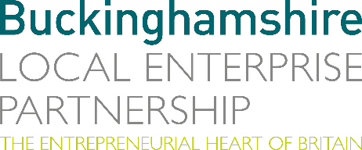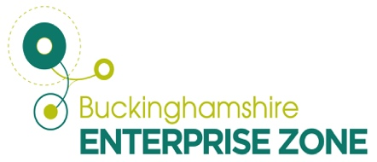
6 July 2023
N E W S R E L E A S E

Fledgling space firm given launch boost thanks to special scheme

Directors of a start-up firm which helps with manufacturing in space are celebrating after being the first business to benefit from a new funding and development initiative.

Growbotics Space has joined the Westcott Incubator and Accelerator (WIA) Programme aimed at encouraging start up and SME companies to grow and develop at Westcott Venture Park in Buckinghamshire.

The business has been awarded £20,000 after being accepted onto the incubator section of the £500,000 scheme and will also have support and use of facilities at the Westcott Innovation Centre.

Buckinghamshire Local Enterprise Partnership launched and funded the programme and appointed the Satellite Applications Catapult (SAC) to run it through its existing facilities at the Westcott Space Cluster.

Growbotics Director Portia Bowman said: “Access to the Catapult team and Westcott facilities is really helpful. We have a lot of space sector knowledge but need help with manufacturing and robotics specifically so cross-sector transferral will be very useful.

“The incubator programme will help our business strategy and market analysis and hopefully we will also be accepted onto the accelerator programme to develop hardware. The aim is to access the robotics lab and start rapidly prototyping.”

Growbotics Space launched at the end of last year and now has two people working in the business, but it has hugely ambitious plans moving forward.

Portia added: “We want to build an in orbit circular economy. Currently, satellites are single use but now the technology exists to dock with them, like a roadside recovery vehicle, we need to design them differently enabling them to be repaired rather than disposed of.

“This means their life can be extended by maintaining and upgrading them instead of launching new satellites that burn up in the atmosphere when we don’t know what damage that is causing.”

Growbotics Space wants to expand its workforce by hiring a mechanical engineer this year, growing the team to about seven people by the end of 2024.

Portia is keen to encourage other developing space-related start-up firms to join the programme so a community of like-minded entrepreneurs can work together on concept development.

She added: “I’m excited about being part of the In-Orbit Servicing and Manufacturing Facility and the collaboration opportunities being part of the Westcott Space Cluster will provide.”

As for the application process, Portia said it was “really easy” with the most challenging part creating a pitch confined to just five minutes.

The Incubator programme offers support of between £5,000-£20,000 to develop projects. The aim is to accelerate prototyping of the next generation of products and services for the space and related sectors.

Matt Peachey, Head of Enterprise Zone Development for Bucks LEP, said: “Through this programme we are determined to attract and support innovative and ambitious UK start-up companies to become part of the Westcott Cluster. Growbotics is an excellent example of this.

“I am sure they will thrive within the space ecosystem at Westcott and we look forward to welcoming more like-minded businesses to the programme soon.”

ENDS

Note to editors
The Buckinghamshire Local Enterprise Partnership (Bucks LEP) is a business-led ‘partnership of equals’ between local government and the private sector, building the conditions for sustainable economic growth in the County.

Buckinghamshire Business First (BBF) is the Growth Hub for the county and is backed by Buckinghamshire-based entrepreneurs, thousands of SMEs, the Buckinghamshire LEP and Buckinghamshire Council. BBF provides the link between public policy and the business community in Buckinghamshire and works with partners to create a dynamic business environment in the Entrepreneurial Heart of Britain.

For further information, contact:

Claire Thompson Papa Romeo PR, M: 07811339577 E: claire@paparomeopr.com

