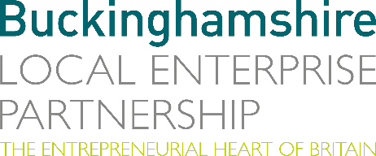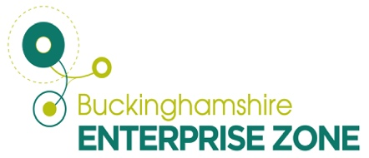
22 August 2022
N E W S R E L E A S E

Funding charges growth for specialist electric vehicle firm

A company which restores and re-engineers a range of vehicles from refuse trucks to classic cars with state-of-the-art electric technology is going from strength to strength with the help of funding sourced by the Buckinghamshire Local Enterprise Partnership (Bucks LEP).

Lunaz was only launched in 2019 and, despite the pandemic, reached a £158m valuation in February following a private capital raise, growing its workforce to 130 employees with a total of 350 skilled jobs set to be created by 2024.

The business, which specialises in converting both refuse trucks and classic cars such as Rolls-Royces, Jaguars and Aston Martins into modern electric vehicles, benefited from Buckinghamshire Enterprise Zone (EZ) rates relief when it started operating from an 8,000 sq ft unit at Silverstone Park.

It has since moved to a 44,000 sq ft facility but demand is such that it has a two-year waiting list for its classic cars. Expansion has also meant the firm is now working on passenger, commercial and industrial vehicles through three divisions - Lunaz Applied Technologies, Lunaz Design and Lunaz Powertrain.

To date, Lunaz has received £130,508 in EZ business rates relief with a further £55,000 for 2022/23 being applied for and the same figure available the following year, making a total of £240,508 which has been reinvested in the business.

Also, the Bucks LEP board approved £614,470 in grant funding from the Government’s Getting Building Fund for R&D into the development of remanufactured and electrified commercial vehicles such as refuse trucks, with Buckinghamshire County Council set to be a customer.

Now it has taken on another 110,000 sq ft industrial unit at Silverstone Park which is set to be operational by October, making it the largest business of its kind in Europe.

Separate investment in the firm has come from David Beckham who has taken a ten per cent stake, along with the Reuben and Barclay families.

David Lorenz, CEO, said: “We are proud to be in Silverstone, a global centre of excellence in manufacturing, engineering and technology and motorsport and we have felt very well supported in Buckinghamshire.

“Rates relief and other support is directly reinvested back into the expansion of our facilities, creates jobs and has a greater economic impact in the area. The support provided by the Bucks LEP Enterprise Zones, as we built the foundations of our business has been absolutely invaluable.”

As well as arranging funding, Bucks LEP will help Lunaz with business advice and support through the Buckinghamshire Skills Hub as it looks to recruit apprentices and young designers.

Richard Harrington, Chief Executive of the Buckinghamshire Local Enterprise Partnership said: “We are proud to have provided rates relief financial support and Getting Building Funding to help establish and grow the Lunaz business. This investment links closely with our strategy to create more opportunity, stimulate additional employment opportunities and generate further productivity in Buckinghamshire.
“The work Lunaz is doing, which not only extends the life of vehicles that would otherwise be scrapped but also electrifies vehicles avoiding millions of tonnes of carbon going into the atmosphere is ground breaking. We are delighted to be supporting this cutting-edge innovation which tackles the climate crisis head on.”

Global governments, including the United Kingdom, have announced bans on the sale of new internal combustion engine vehicles by 2030.

This presents a potent commercial opportunity to build a clean-tech firm and create jobs and positive economic activity in the Buckinghamshire area and is in line with Buckinghamshire County Council’s ambitions for net zero carbon emissions by 2050.

ENDS

Note to editors
The Buckinghamshire Local Enterprise Partnership (Bucks LEP) is a business-led ‘partnership of equals’ between local government and the private sector, building the conditions for sustainable economic growth in the County.

Buckinghamshire Business First (BBF) is the Growth Hub for the county and is backed by Buckinghamshire-based entrepreneurs, thousands of SMEs, the Buckinghamshire LEP and Buckinghamshire Council. BBF provides the link between public policy and the business community in Buckinghamshire and works with partners to create a dynamic business environment in the Entrepreneurial Heart of Britain.

For further information, contact:

Claire Thompson Papa Romeo PR, M: 07811339577 E: claire@paparomeopr.com

