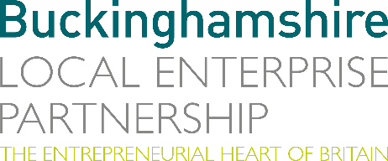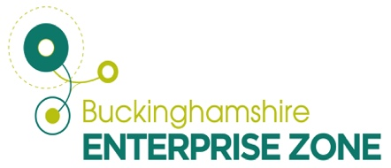
2nd May 2023
N E W S R E L E A S E

Cable manufacturer lines up major growth at Silverstone

One of Europe’s leading niche cable and wiring harness manufacturers is going from strength to strength at Silverstone Park with new investment in equipment and training.

Nicab recently invested £200,000 in a Komax Alpha 530 machine which can crimp and seal high-quality wire cross-sections at a rate of nine metres per second.

Managing Director Nick Locke explained: “This will streamline the business as it automates some of our manual work which in turn frees up capacity to focus on additional work and enables us to compete with China both in terms of pricing and speed of turnaround.

“It means we can attract more business. In terms of targeted growth, we are looking to take on more work in the medical and aerospace sectors.”

Nicab has enjoyed significant growth in the past two years having achieved an annual turnover of more than £2.6m for the first time. It now employs 22 full-time staff compared to 18 this time last year.

Formed in 2010, the company moved to its current premises three years ago and, as part of the Buckinghamshire Local Enterprise Zone, qualified for business rates relief which so far amounts to £55,047 with another two years remaining. The saving has been re-invested into new equipment and staff training.

Nick added: “We have a strong approach to training and apprenticeships and have four apprentices, all in various stages of their progress. The aim is always to keep them within the company once they’ve completed their apprenticeship.
“We also work closely with Silverstone University Technical College (UTC) and MEPC on engaging with schools and UTC students carry out 140 hours of extended work experience with us to fulfil their course.

“Afterwards, if they like what they’ve done with us, we can then consider them for an apprenticeship for the next year, something which happened very recently.”

Matt Peachey, Head of Enterprise Zone Development at Buckinghamshire Local Enterprise Partnership said: “Nicab is a is a great example of a Buckinghamshire business with a strong approach to training and apprenticeships and we are delighted to be able to support them as they grow skills amongst our workforce.

“The company has enjoyed significant growth and its investment into the Komax machine adds further value, laying the grounds for future growth and job security for its employees.”

As well as medical and aerospace, other sectors Nicab is involved with include industrial, defence, automotive and audio visual. While the Komax machine speeds up production, considerable skill is still required to do the job.

Nick added: “We very much see ourselves as craftspeople – much of what we do, particularly the more complex stuff, still needs to be conducted by hand despite automation. These are skills that can take years to learn and are of real value to customers.”

Nicab is also on the way to gaining Investors in People accreditation which it hopes to achieve by the third quarter of this year while Nick participated in the Buckinghamshire Business First Lean and Growth programme which he found useful.

ENDS

Note to editors
The Buckinghamshire Local Enterprise Partnership (Bucks LEP) is a business-led ‘partnership of equals’ between local government and the private sector, building the conditions for sustainable economic growth in the County.

Buckinghamshire Business First (BBF) is the Growth Hub for the county and is backed by Buckinghamshire-based entrepreneurs, thousands of SMEs, the Buckinghamshire LEP and Buckinghamshire Council. BBF provides the link between public policy and the business community in Buckinghamshire and works with partners to create a dynamic business environment in the Entrepreneurial Heart of Britain.

For further information, contact:

Claire Thompson Papa Romeo PR, M: 07811339577 E: claire@paparomeopr.com

