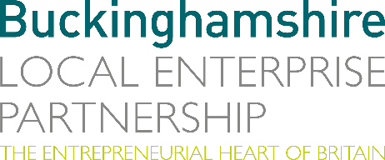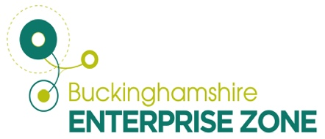
No. 006.23 4th April 2023
N E W S R E L E A S E

New Enterprise Zone Head for Bucks

Matt Peachey formerly of Oxford City Council has been named as the new Head of Enterprise Zone Development for Buckinghamshire.

Matt is an accomplished Economic Development Manager with extensive experience working with partners to attract investment into local areas across the country. He will play a key role in accelerating growth and innovation of Buckinghamshire’s Enterprise Zones (Bucks EZ) at Silverstone Park, Westcott Venture Park and Arla Woodlands.

Bucks EZ works with landowners, business, sector bodies and government to drive growth and enterprise in Buckinghamshire. It secures public and private investment to deliver a range of programmes and initiatives with partners to help businesses grow.

Richard Harrington, Chief Executive of the Buckinghamshire Local Enterprise Partnership (Bucks LEP) said: “Matt’s appointment is a welcome addition to the Bucks LEP EZ team which has built strong foundations to help the business community grow over the past decade.

“Matt brings a wealth of experience which will enable us to drive development in key growth sectors and lead on innovation strategy initiatives for the area. This comes at a significant time for the Bucks EZ sites, which have delivered 55% of all new commercial and industrial employment space in Buckinghamshire since their inception.

“There is significant potential to further strengthen and enhance growth initiatives across Silverstone, Westcott and Arla Woodlands.”

Matt’s bold plans for growth will see further development of the space propulsion, engineering, high performance technology, motorsport and agri-food and human health sectors, supporting local wealth creation and productivity in the county.

Matt Peachey said: “My role is to have the right conversations with landowners, businesses and wider partners in academia, and government to help drive forward our Enterprise Zone in ways which benefit our nationally significant clusters and wider economy. There is still a need for us to co-invest with our partners, to ensure that each Enterprise Zone realises its full potential.

“I am excited about developing further collaboration and support across the Bucks EZ sites and the specialist business clusters within, including the Westcott Space Cluster and the Silverstone Technology Cluster.”

A host of projects have come to fruition across Buckinghamshire over the past 12 months. Local Growth Fund and Getting Building Fund investments have helped support the development of businesses within the Bucks EZ including the Silverstone Sports Engineering Hub, the Satellite Applications Catapult’s In-Orbit Services and Manufacturing facility and the new Drone Test and Development Centre, both at the Westcott Enterprise Zone.

This year funding is being provided to support initiatives including the new Cycling Test Lab and Swimming Flume at the Silverstone Sports Engineering Hub and the Agri Living Lab at our Westcott Enterprise Zone.

Buckinghamshire Local Enterprise Partnership has also launched the £500,000 Westcott Accelerator and Incubation Programme, designed to help start up and SME companies to grow and develop at the Westcott Enterprise Zone.

ENDS

Note to editors
The Buckinghamshire Local Enterprise Partnership (Bucks LEP) is a business-led ‘partnership of equals’ between local government and the private sector, building the conditions for sustainable economic growth in the County.

Buckinghamshire Business First (BBF) is the Growth Hub for the county and is backed by Buckinghamshire-based entrepreneurs, thousands of SMEs, the Buckinghamshire LEP and Buckinghamshire Council. BBF provides the link between public policy and the business community in Buckinghamshire and works with partners to create a dynamic business environment in the Entrepreneurial Heart of Britain.

For further information, contact:

Claire Thompson Papa Romeo PR, M: 07811339577 E: claire@paparomeopr.com

