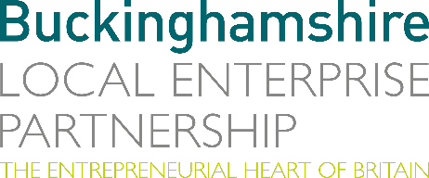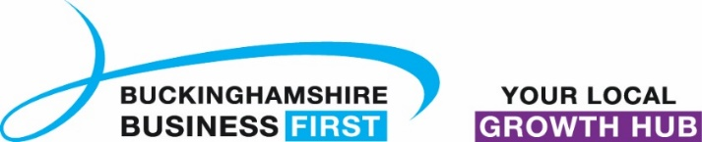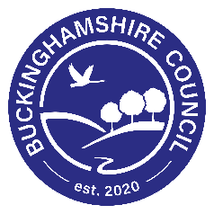

No. 007.20 26 March 2020
N E W S R E L E A S E

Additional £2 Million of Covid 19 emergency funding made available to support Bucks businesses

Buckinghamshire Local Enterprise Partnership (Bucks LEP) are making available £2 million additional funding to support businesses in the county affected by the Covid 19 (coronavirus) crisis. The Bucks LEP Board held an Extraordinary Board meeting to approve the release of £2 million to be administered by its Growth Hub, operated by Buckinghamshire Business First, as part of the Buckinghamshire Business Resilience Support Fund. This funding is part of a co-ordinated support programme for business with the LEP working closely alongside Buckinghamshire Business First and Buckinghamshire Council.

This new fund is part of a partnership between Bucks LEP, Buckinghamshire Business First and Buckinghamshire Council, to support the Buckinghamshire Resilience programme. The new fund has been set up to provide immediate support for local businesses, whose cash-flow and future viability has been adversely impacted by Covid-19 and to support Buckinghamshire businesses switch operational practices and production schedules to support the local and national resilience programme.

The fund is aimed at complementing national commitments and will provide funding for the smaller and micro-businesses that would not automatically qualify for Government support. It is hoped that other funding can be attracted from local and
more…

Additional £2 Million of Covid 19 emergency funding made available: 2

national sources over the coming weeks to extend the reach to more businesses across the county.
Andrew M. Smith, Chair of Buckinghamshire Local Enterprise Partnership, said: “The Chancellor’s package of measures for business support is widely welcomed and clearly recognises the enormous scale of the challenge faced by business and business leaders. This fund is intended to complement those national measures already in place, to support Buckinghamshire businesses to assist with the emergency response and to assist with remote and flexible working practices that are essential at this time. The speed of response is critical in supporting successful at-risk businesses in Buckinghamshire, as business leaders ourselves we knew that it was important to move swiftly to help make a difference where we can.”
Michael Garvey, Chair of Buckinghamshire Business First added: “Over the past two weeks we have heard from many Buckinghamshire businesses impacted by this situation, a single recurring message is coming across loud and clear, swift access to cash is needed to prevent otherwise healthy companies from going under, and people losing their jobs and their income. Bucks Business First is here to support and help all local businesses at this difficult time, if your business is being affected please visit www.bbf.uk.com/covid-19.”
Councillor Martin Tett, Leader of Buckinghamshire Council said: “It is important at this time that all local partners work closely together to support the resilience of our communities and businesses and to swiftly provide resources when and where they will be most effective. I am pleased to be able to support this joined up approach, making staff available to help administer the new fund and support the enquiries from businesses from across the county. Together with the incredible support of the Buckinghamshire MPs we are able to ensure that the needs and concerns of our business are heard at the heart of Government.”
more…

Additional £2 Million of Covid 19 emergency funding made available: 3

The fund is part of a package of support being provided for local businesses. Buckinghamshire Council are working to make the process for businesses receiving business rate discounts and additional Government backed grant support as simple as possible. All eligible businesses will be notified shortly of the measures that have been put in place to access any rate deferrals or funding.

Any business that is being affected by COVID-19 (coronavirus) or has concerns about its future impact on business, can visit the website bbf.uk.com/covid-19 where the most up-to-date advice and support is being collated including full details of the funding criteria and the online application for the Buckinghamshire Business Resilience Fund.

Ends
Note to editors
The Buckinghamshire Local Enterprise Partnership (Bucks LEP) is a business-led ‘partnership of equals’ between local government and the private sector, building the conditions for sustainable economic growth in the County.

Buckinghamshire Business First (BBF), is the Growth Hub for Buckinghamshire and is backed by Buckinghamshire based entrepreneurs, thousands of SMEs and Local Authorities. BBF provides the link between public policy and the business community in Buckinghamshire and works with partners to create a dynamic business environment in the Entrepreneurial Heart of Britain.

Buckinghamshire Council
From 1 April 2020, the new Buckinghamshire Council will replace the existing district and county councils of Buckinghamshire.

For further information please contact:
Richard Burton
Communications Manager, Buckinghamshire LEP

T: 01494 927160
M: 07866 492292
E: richard.burton@btvlep.co.uk

