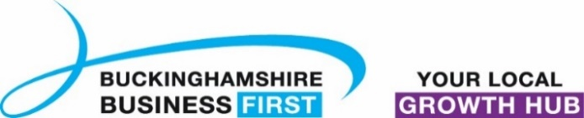
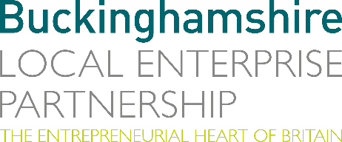
No. 012.22 18 May 2022
N E W S R E L E A S E

What barriers are slowing you down on your journey to Net Zero emissions?

Buckinghamshire Local Enterprise Partnership (Bucks LEP) and Buckinghamshire Business First are seeking the views of local businesses for the latest Buckinghamshire Business Barometer survey, which seeks views in particular about the barriers businesses are facing towards achieving Net Zero emissions.

“Help is at hand for businesses that are reducing or want to reduce their carbon emissions,” explains Philippa Batting, Managing Director, Buckinghamshire Business First. “For more than a decade, Buckinghamshire Business First has taken a lead role in influencing, educating, and supporting local businesses to make practical changes to reduce carbon emissions and improve energy efficiency.”

Philippa added: “We are urging businesses to get involved and answer a few quick questions as part of the Business Barometer to help us ensure effective support is in place to tackle the challenge head-on over the next critical decade.”

James Moorhouse, Economic & Labour Market Analyst at Buckinghamshire Local Enterprise Partnership, said: “Your survey answers will help us to gain valuable insights into the local economy which will feed into our conversations with Government and other stakeholders. In addition, your answers and experiences will also form part of a green economy audit carried out by Bucks LEP to identify opportunities for Net Zero growth.”

more…

What barriers are slowing you down on your journey to Net Zero: 2

In addition, submissions received by 10th June will be entered into prize draw to win an EV Track Experience at the Silverstone Circuit! (Terms and conditions apply). The Business Barometer survey can be found at: https://ecv.microsoft.com/7DIAcixwDF

As with each Business Barometer survey, the aim is to know how businesses have fared in the last few months in order to help build a picture of the needs and opportunities that exist in the Buckinghamshire business community.

Last quarter’s Buckinghamshire Business Barometer report can be downloaded at:
www.buckseconomy.co.uk/business-and-innovation/business-innovation-research-reports/#Business-Innovation-Buckinghamshire-Business-Barometer

Ends

Note to editors

The Buckinghamshire Business Barometer is run by Buckinghamshire Business First and Buckinghamshire Local Enterprise Partnership. The Barometer began in 2021 and is conducted via an online survey on a quarterly basis. The survey can be completed by any business operating within Buckinghamshire and is promoted to businesses through Buckinghamshire Business First and its partners. Respondents are self-selecting and the results are not weighted, therefore the findings should be treated as indicative rather than representative of all Buckinghamshire businesses.

The Buckinghamshire Local Enterprise Partnership (Bucks LEP) is a business-led ‘partnership of equals’ between local government and the private sector, building the conditions for sustainable economic growth in the County.

Buckinghamshire Business First (BBF) is the Growth Hub for the county and is backed by Buckinghamshire-based entrepreneurs, thousands of SMEs, the Buckinghamshire LEP and Buckinghamshire Council. BBF provides the link between public policy and the business community in Buckinghamshire and works with partners to create a dynamic business environment in the Entrepreneurial Heart of Britain.

For further information, please contact:
Richard Burton MCIPR, MPRCA
Communications Manager, Buckinghamshire LEP

T: 01494 927160
M: 07866 492292
E: richard.burton@buckslep.co.uk

