No. 028.18 16 October 2018

N E W S R E L E A S E
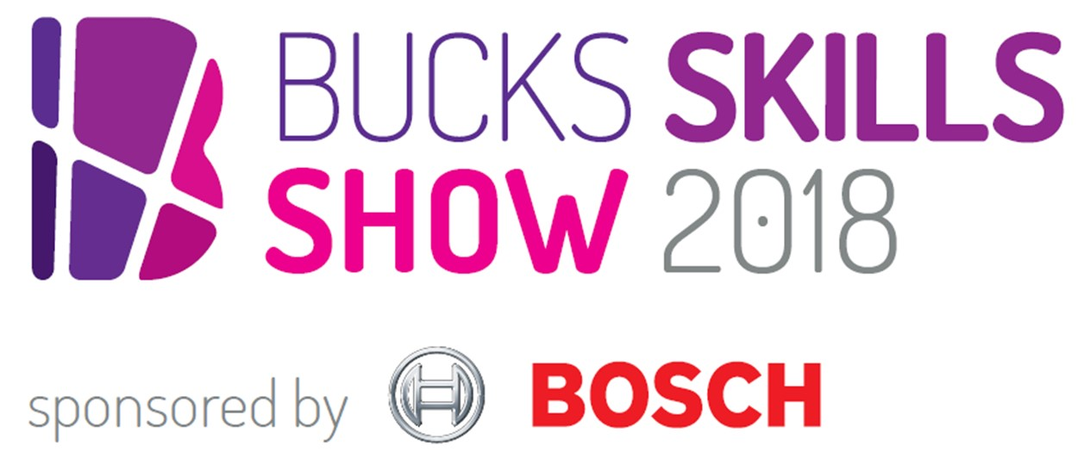
Skills Show ‘brings careers to life’ for 3000

Three thousand visitors saw careers brought to life at the Bucks Skills Show last week (Friday 12 and Saturday 13 October) – thanks to a range of interactive experiences from sweetie selfies created with cutting edge 3D printing technology to immersive virtual reality demonstrations.

Students, teachers and parents headed to The Gateway in Aylesbury over two days to take part in the county’s largest careers fair sponsored by technology giant Bosch. Attendance at the event was up 100% on last year, and attracted over 100 high profile exhibitors including Jaguar Land Rover, the NHS, Pinewood Studios, HS2 and Danesfield House Hotel.

It also drew in speakers from Google, the Ministry of Sound, ITV News and MP and Minister for the Cabinet the Rt Hon David Lidington. This year it also featured a new space industries area and a strong showing from the music trade.

Marina Jackson, Under 19 Skills Manager at event organiser, Bucks Skills Hub, part of Buckinghamshire Thames Valley Local Enterprise Partnership, enthused: “We couldn’t have done it without the support of Bosch and all our other exhibitors. It was

more…
Skills Show ‘brings careers to life’ for 3000: 2

wonderful to see students asking questions of employers, speakers and in the jobs and apprenticeship workshops – and gaining real insight through the interactive exhibits such as Bosch’s immersive virtual reality headsets and power tools workshop, which really brought careers to life.”

Mark Warrilow, Skills Manager at HS2, said: “The Bucks Skills Show is a best-in-class example of what can happen when local schools, colleges, and employers come together to showcase the opportunities in skills, employment, and education. Alongside our supply chain partners Eiffage-Kier, Align, and Fusion, we were very proud to come away with the Best Stand Award, and inspired by the quality of conversations we had over the weekend talking to the next generation of HS2 engineers.”

Application Engineer Stephanie Alexander from Bosch shared her career journey with students on the day and gave them tips on achieving their own success: “Bosch is proud to sponsor such an enlightening event for young people in the local area and delighted to headline the Engineering, Technology and Manufacturing zone.”

Jackie Campbell, Skills Development Lead for the Buckinghamshire Thames Valley Local Enterprise Partnership, added: “There is a world of opportunity in sectors of local and national significance in Bucks, including creative industries, high performance engineering, space industries and construction, and our support to build the skilled workforce that business needs starts here at the Bucks Skills Show, and continues in schools and colleges across the county.”

To see more of the action at the event – and to get the date in your diary for 2019 – follow @BucksSkillsShow on Twitter.

Ends

Photo caption: From sweetie selfies created with cutting edge 3D printing technology to immersive virtual reality demonstrations, students witnesses careers brought to life at the Bucks Skills Show sponsored by Bosch on Friday 12 and Saturday 13 October.

Note to editors
The aim of BTVLEP’s Skills Hub – one of the first LEPs to develop such a hub – is to make a difference to young people’s employability while addressing the needs of employers. In Bucks, the level of employer engagement activity in schools can vary from school to school, and the Buckinghamshire Skills Hub is working to ensure all schools have access to effective and impactful employer interactions.

In order to help young people gain the valuable, constructive, rewarding work experience required, the Bucks Skills Hub has launched WANNABE (www.wannabebucks.org) where employers can post opportunities for young people to apply for. The site provides extensive information, guidance, a careerometer tool to explore earning potential and career prospects, as well as work experience, apprenticeship and part/full time job vacancies. Young people can look for work experience opportunities which are in line with their ambitions, rather than perhaps spending time at their parents’ place of work or finding placements via their parents’ network. There is a broad range of opportunities for young people to apply for.

The Buckinghamshire Thames Valley Local Enterprise Partnership (BTVLEP) is a business-led ‘partnership of equals’ between local government and the private sector, building the conditions for sustainable economic growth in the County. Formed in January 2012, the partnership balances a uniquely strong collective business voice with a cohesive elected local leadership. Coming together to engineer the conditions needed to drive forward business prosperity in the county and beyond, BTVLEP recognises that an important part of this is to support education and skills providers and employers to ensure our young people have the right skills to meet the needs of the economy, including the growth sectors such as life-sciences, space, creative industries and advanced engineering.

Buckinghamshire Business First (BBF), is the Growth Hub for Buckinghamshire and is backed by Buckinghamshire based entrepreneurs, thousands of SMEs and Local Authorities. BBF provides the link between public policy and the business community in Buckinghamshire and works with partners to create a dynamic business environment in the Entrepreneurial Heart of Britain.

For further information please contact:
Richard Burton
Communications Manager

T: 01494 568933
M: 07866 492292
E: richard.burton@btvlep.co.uk

