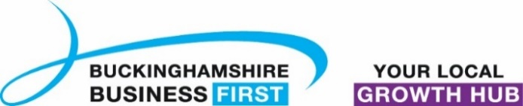
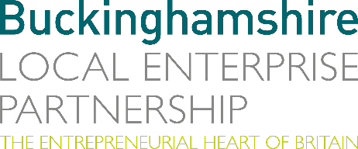
No. 030.21 9 December 2021
N E W S R E L E A S E

Survey shows trading conditions improved for Bucks businesses and more were looking to invest in their future

Buckinghamshire Local Enterprise Partnership and Buckinghamshire Business First’s latest Buckinghamshire Business Barometer survey shows trading conditions improving for Buckinghamshire businesses going into the Autumn, and more were looking to invest in their future than in the previous quarter, however, challenges remain, in particular rising costs.

The Buckinghamshire Business Barometer* survey results provide us with much to be positive about. In the third quarter of the year (July to September 2021):
- Most businesses reported ‘normal’ or ‘better than normal’ trading conditions.
- Whilst 30% reported ‘worse than normal’ training conditions, this was down from 74% in the first three months of the year, a considerable improvement.
- There was an increase in businesses reporting ‘better than normal sales’, turnover and orders/ pipeline for the time of year.
- More business told us they plan to invest in their business over the next three months than in the previous two quarters.

Caroline Perkins, Research Manager at Buckinghamshire Local Enterprise Partnership, said: “Looking at these results with other available data, it does appear that Buckinghamshire businesses have weathered the stormy waters of 2020 and 2021 comparatively well. However, getting to this point has not been easy. Many business leaders have had to dig deep to keep their businesses alive in the face of the twin challenges of both Covid-19 and EU transition, and their knock-on effects.
more…
Survey shows trading conditions improved for Bucks businesses: 2

“One of the most challenging aspects of both has been increased costs, which have been added to by high energy and fuel costs in the second half of the year.”

In total, approximately 65% of businesses surveyed said that their business had experienced extra costs during the period July to September (Q3) 2021. Extra costs are likely to be one of the main reasons why improving sales, turnover and orders have not yet translated into increased profits.

Going into the winter, Covid-19 uncertainty is re-emerging, which may dampen the optimism businesses were feeling at the time of the survey. Whilst many are now much better equipped to deal with the challenges Covid-19 presents, those operating in sectors most badly affected (e.g., hospitality, travel and events) have begun to see customers become more cautious and therefore their hopes for a prosperous Christmas period are fading.

Therefore, whilst there is much to be positive about, not least how Buckinghamshire businesses have reacted and adapted to the many challenges they have faced, and therefore the extent to which the economy has bounced back, bumps are likely to still remain on the road ahead.

The full Buckinghamshire Business Barometer report for quarter 3 2021 can be downloaded from here: https://www.buckseconomy.co.uk/business-and-innovation/business-innovation-research-reports/#Business-Innovation-Buckinghamshire-Business-Barometer

Any Buckinghamshire businesses who would like to participate in the next Barometer survey, can register their interest via info@bbf.uk.com.

Ends

* quarterly survey run by Buckinghamshire LEP and Buckinghamshire Business First
Note to editors

The Buckinghamshire Business Barometer is run by Buckinghamshire Business First and Buckinghamshire Local Enterprise Partnership. The Barometer began in 2021 and is conducted via an online survey on a quarterly basis. The survey can be completed by any business operating within Buckinghamshire and is promoted to businesses through Buckinghamshire Business First and its partners. Respondents are self-selecting and the results are not weighted, therefore the findings should be treated as indicative rather than representative of all Buckinghamshire businesses.

Previous editions of the Buckinghamshire Business Barometer can be accessed here.

The Buckinghamshire Local Enterprise Partnership (Bucks LEP) is a business-led ‘partnership of equals’ between local government and the private sector, building the conditions for sustainable economic growth in the County.

Buckinghamshire Business First (BBF) is the Growth Hub for the county and is backed by Buckinghamshire-based entrepreneurs, thousands of SMEs, the Buckinghamshire LEP and Buckinghamshire Council. BBF provides the link between public policy and the business community in Buckinghamshire and works with partners to create a dynamic business environment in the Entrepreneurial Heart of Britain.

For further information, please contact:
Richard Burton MCIPR, MPRCA
Communications Manager, Buckinghamshire LEP

T: 01494 927160
M: 07866 492292
E: richard.burton@buckslep.co.uk

