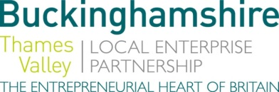
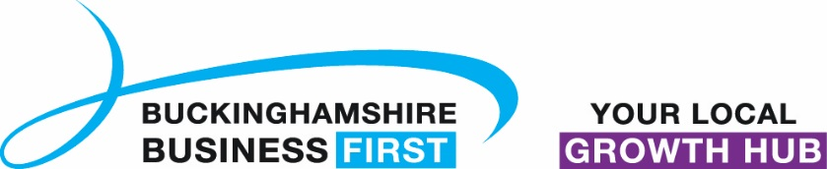

No. 031.18 3rd December 2018
N E W S R E L E A S E

New board members sought by Buckinghamshire Thames Valley

Local Enterprise Partnership

Business people are being invited to join the board of the Buckinghamshire Thames Valley Local Enterprise Partnership (BTVLEP), to help to help steer the future of an area with an economic output worth over £16 billion.

BTVLEP is a business led Local Enterprise Partnership which promotes economic growth and prosperity across Buckinghamshire. Bucks is a significant wealth generator for the UK economy, and the commitment of over £73m in Local Growth Funds is unleashing ambition and creativity in the county. This funding is enabling the delivery of new road and rail infrastructure, better skills and business opportunities and enhancing digital connectivity to support sustainable economic growth in Bucks which sits at the heart of the Oxford-Cambridge Arc.

In the past 12 months our Local Growth Fund investment has helped support new educational facilities at the world leading National Film and Television School, new facilities for the creative industries and construction and motor trades have been created at the Buckinghamshire College Group sites and work is now complete on the new Vinson Centre for Entrepreneurship at the University of Buckingham. This
more…

New board members sought by BTVLEP: 2

performance in our Local Growth Fund Delivery has enabled BTVLEP to be graded good on all fronts in the Government’s annual assessment of Local Enterprise Partnerships.

Andrew M. Smith, Chair of Buckinghamshire Thames Valley Local Enterprise Partnership, said: “BTVLEP is recognised by Government to be a high-performing LEP, these new board appointments will support the continued growth of our economy and help our businesses to flourish locally and internationally.”

Andrew added: “We are seeking applications from new private sector board members who will bring further commercial experience and insight to the board and help generate new ideas and who will best reflect the communities we serve across Buckinghamshire.”

A Board Members role is to use their business knowledge to give strategic advice on boosting the area’s economy; promote LEP interests when dealing with Government and business contacts; help drive forward the LEP’s activities, including those around increasing jobs and business growth; contribute to development and delivery of the area’s Local Industrial Strategy; and champion the work of the BTVLEP Board to relevant partners, networks and other business organisations.

Applicants should be excellent communicators, demonstrate real leadership, understand what drives economic prosperity, have a good knowledge of the area and its needs, and possess extensive business networks and contacts. They must also be available to serve on the BTVLEP board for up to four years, and to attend regular meetings and events.

The closing date for applications is December 21st with interviews being held in the week commencing January 7th 2019.
more…

New board members sought by BTVLEP: 3

Applicant packs, including a role description and person specification, can be requested by contacting info@btvlep.co.uk or telephoning 01494 927132. In addition, further details can also be found on the BTVLEP website at: www.buckstvlep.co.uk/board-members/board-appointments

Buckinghamshire is the Entrepreneurial Heart of Britain where, for well over a decade, more businesses have started here than anywhere else in the UK. This is borne of the heartbeat of enterprise, which is manifest in a propensity to act; and a
propensity to successfully exploit new ideas. It is no accident that we are the Birthplace of the Paralympics at Stoke Mandeville, the creative film engine for James Bond and Star Wars at Pinewood Studios, and the joint home of the Silverstone Grand Prix Circuit.
Ends

Note to editors
The Buckinghamshire Thames Valley Local Enterprise Partnership (BTVLEP) is a business-led ‘partnership of equals’ between local government and the private sector, building the conditions for sustainable economic growth in the County.

Buckinghamshire Business First (BBF), is the Growth Hub for Buckinghamshire and is backed by Buckinghamshire based entrepreneurs, thousands of SMEs and Local Authorities. BBF provides the link between public policy and the business community in Buckinghamshire and works with partners to create a dynamic business environment in the Entrepreneurial Heart of Britain.

For further information please contact:
Richard Burton
Communications Manager

T: 01494 927160
M: 07866 492292
E: richard.burton@btvlep.co.uk

