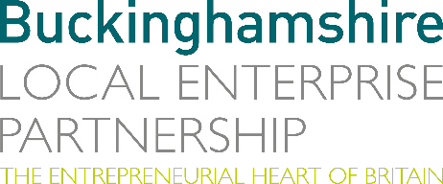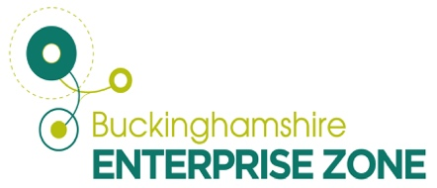
30th November 2023
N E W S R E L E A S E

Drone technology firm flying high thanks to contract wins

A company using drones to deliver cargo, food and medical supplies to remote locations has seen demand for its services take off.

Skyports Drone Services, based in the Westcott Space Cluster, is going from strength to strength thanks to a clutch of contracts from across the world.

They include:
- The launch of a new project in Yeosu, Korea, for the delivery of pharmaceuticals and foodstuffs by drone. Phase one will see regular flights between the Yeosu mainland and three islands, Gaedo, Geumodo and Songdo, bridging communities in hard-to-reach parts of the region.

- Successful participation in phase two of the Royal Navy Uncrewed Aerial Systems Heavy Lift Challenge (UASHLC) with the Pyka Pelican Cargo, a fully autonomous and 100 per cent electric, heavy-payload aircraft. This involved transporting medical supplies and equipment for the Navy’s humanitarian aid projects.

- Providing pilots to operate regular data acquisition missions for Australian drone manufacturer Carbonix’s energy infrastructure and mining partners using a long-range vertical take-off and landing aircraft.

- Trialling electric drone deliveries of spare parts, equipment and care packages to oil installations in the North Sea in a partnership with Norwegian energy firm Equinor.

- The delivery of more than 400 pathology samples between two sites operated by the East Suffolk and North Essex NHS Foundation Trust in a trial for healthcare logistics provider EMED Group. It highlighted how drones can enhance traditional medical courier services and improve delivery for patients and healthcare professionals.

The contracts come in addition to previous trials including Beyond Visual Line of Sight drops in Kenya, school meal deliveries in Scotland and the transport of Covid-19 test samples and other medical materials between healthcare facilities in the Argyll and Bute region.

Michael Merritt, Strategy and Operations Manager of Skyports Drone Services, said: “It has been an amazing year for Skyports during which we have consistently proved how drone services and expertise can make a real difference for communities and critical operations across the world.

“Westcott is proving to be a fantastic home for us with so many like-minded companies on site and their support and that of the Buckinghamshire Local Enterprise Partnership has been invaluable as we continue to expand our operations.”

Skyports is now based at the Westcott Drone Test and Development Centre which Bucks LEP invested in via the Government’s Getting Building Fund and is one of the foremost facilities of its kind in Europe.

The company was also a key part of a recent consortium led by URA Thrusters and including Bucks LEP and Plastron UK which successfully won £5.9m from the Space Cluster Infrastructure Fund to make substantial contributions to the advancement of space research, manufacturing, and testing.

Matt Peachey, Head of Enterprise Zone Development at Buckinghamshire LEP, said: “Skyports is another example of a Buckinghamshire company flourishing thanks to a combination of pioneering innovation, technical expertise and a great working environment supported by strategic funding.

“We look forward to seeing the company continue to grow, and hopefully be joined by many other players in the sector as Westcott becomes a global hub for drone technology.

“The cutting-edge Drone Test and Development Facility at Westcott has been made possible with £1.4 million investment from Getting Building Funds. The facility has gained significant popularity due to the growing demand for this capability in the sector. The centre, operated by the Satellite Applications Catapult, is currently in discussions with several operators to establish their presence at the facility.”

ENDS

Note to editors
The Buckinghamshire Local Enterprise Partnership (Bucks LEP) is a business-led ‘partnership of equals’ between local government and the private sector, building the conditions for sustainable economic growth in the County.

Buckinghamshire Business First (BBF) is the Growth Hub for the county and is backed by Buckinghamshire-based entrepreneurs, thousands of SMEs, the Buckinghamshire LEP and Buckinghamshire Council. BBF provides the link between public policy and the business community in Buckinghamshire and works with partners to create a dynamic business environment in the Entrepreneurial Heart of Britain.

For further information, contact:

Claire Thompson Papa Romeo PR, M: 07811339577 E: claire@paparomeopr.com

