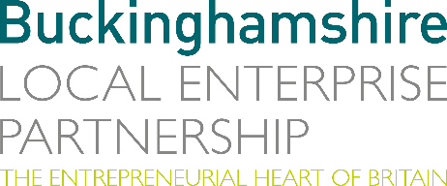
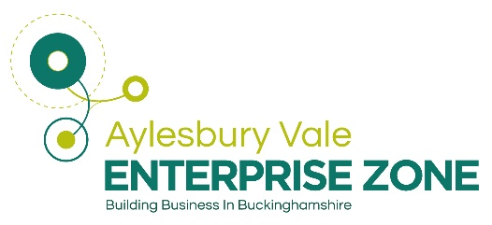
No. 009.20 11 June 2020
N E W S R E L E A S E

New website keeping you informed on latest developments

across Buck’s Enterprise Zones

Buckinghamshire Local Enterprise Partnership (Bucks LEP) is delighted to announce the launch of its new website, which aims to provide latest information on key developments across Buckinghamshire’s Enterprise Zones.

Since 2016 the Aylesbury Vale Enterprise Zone has provided an enormous boost to help Buckinghamshire grow its existing businesses and attract and accelerate new investment in key business sectors at Bucks LEP’s three strategically important Enterprise Zone sites.

Anthony Sowden, Director, Aylesbury Vale Enterprise Zone, said: “The scale and special nature of the development, the mix of uses and the highly strategic position, at the heart of the ‘Oxford to Cambridge Arc’ enables the Aylesbury Vale Enterprise Zone sites to compete nationally and internationally as major employment locations. The aim of this new website is to showcase the latest development activities across these three sites and highlight the benefits for businesses locating to Aylesbury Vale Enterprise Zone.”

More…

New website keeping you informed on latest developments: 2

Four years on, the sites at Silverstone Park, Westcott Park and at Aylesbury Woodlands are driving forward the Buckinghamshire economy in the sectors of high-performance engineering, space technology and life sciences – all critical to the national economy and just as importantly securing business rate returns to be reinvested into the local economy.

Since Enterprise Zone status was granted to these three sites in 2016, there has been major growth and investment, resulting in: 44,370 m2 of floorspace completed; 25,190 m2 of floorspace under construction; 32 new businesses established; over 300 jobs created; more than £50m private sector investment; and £11.5m project funding committed to support the growth of Aylesbury Vale Enterprise Zone.

To find out about the latest information on the activities of the Aylesbury Vale Enterprise Zone please go to our new website at: www.aylesburyvaleez.co.uk

Bucks LEP is a business led Local Enterprise Partnership which promotes economic growth and prosperity across Buckinghamshire. Bucks is a significant wealth generator for the UK economy, and the commitment of over £73m in Local Growth Funds is unleashing ambition and creativity in the county. This funding is enabling the delivery of new road and rail infrastructure, better skills and business opportunities and enhancing digital connectivity to support sustainable economic growth in Bucks, which sits at the heart of the Oxford-Cambridge Arc.

Ends

Note to editors
Milestones for individual Enterprise Zone sites:

Silverstone:
- Phase 1 development 11,665m2 floorspace completed and 100% occupied (12 companies) by January 2019;
- Phase 2 Development 23,990m2 floorspace under construction - completion due Q3 2020/21;
- Phase 3 Development 24,632m2 floorspace - detailed planning application submitted April 2020;
- Unit 1129 (Silverstone Sports Engineering Hub) supported by £2m LGF - opened February 2019;
- EZ Multi Utility Infrastructure Project - £5m funding support from AVEZ - completed January 2020 - providing utilities to enable Ph 2 / Ph 3 & future Silverstone EZ Phases.

Westcott:
- 1,700m2 Offices / production facility for Reaction Engines SABRE engine -completed 2019 - SABRE test facility under construction and due to be operational in 2021;
- 5G Step out Centre (£0.6m LGF) and Business Incubation Centre (£0.5m ERDF) completed 2018 - supporting 15+ start-up businesses;
- Westcott Site Access Improvements including new A41 roundabout (£1.7m EZ funding support) under construction - completion Q3 2020/21;
- 1,200m2 Innovation Centre under construction by Satellite Applications Catapult (£3.2m LGF / EZ Funding) - completion due Q3 2020/21;
- National Space Propulsion Test Facility (£4m UKSA funding) - Planning application submitted April 2020 - completion by Q 4 20/21.

Woodlands:
- Green Energy Plant (6,500m2 floorspace) completed by Olleco Ltd (November 2017);
- Ph 1 Symmetry Park (23,100m2 floorspace) 3 Units completed Q4 2019/20 - unit 1 occupied by Global Infusions in 2019 / planning application for film production facility submitted for unit 3 in Feb 20;
- Ph 2 Symmetry Park - detailed planning consent for up to 34,930m2 floorspace;
- Woodlands - Resolution to grant Outline Planning Consent (October 2017) for 102,400m2 employment floorspace in EZ and 1,00 homes - planning consent anticipated Q3 20/21.

The Buckinghamshire Local Enterprise Partnership (Bucks LEP) is a business-led ‘partnership of equals’ between local government and the private sector, building the conditions for sustainable economic growth in the County.

Buckinghamshire Business First (BBF), is the Growth Hub for Buckinghamshire and is backed by Buckinghamshire based entrepreneurs, thousands of SMEs and Local Authorities. BBF provides the link between public policy and the business community in Buckinghamshire and works with partners to create a dynamic business environment in the Entrepreneurial Heart of Britain.

For further information please contact:
Richard Burton
Communications Manager

T: 01494 927160
M: 07866 492292
E: richard.burton@btvlep.co.uk

