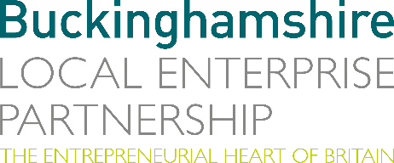
No. 029.21 8 December 2021
N E W S R E L E A S E

Online Annual Report Brings Year of Achievements to Life!

Buckinghamshire Local Enterprise Partnership (Bucks LEP) is delighted to launch its first web-based annual report, which brings to life all the achievements of Bucks LEP over the past 12 months.

The interactive annual report includes video, ‘drop-down’ imagery and infographics and links to further content and partner information, to create an eye-catching visual experience.

Richard Harrington, Chief Executive of Buckinghamshire Local Enterprise Partnership, said: “This year’s annual report takes a fresh approach to the content and design element of the report. In particular, we have produced a web-based report which is more interactive and visually appealing to clearly highlight our achievements over the past twelve months and our plans for the future.”

This year’s annual report highlights a flurry of projects that came to fruition right across Buckinghamshire. In the past 12 months Local Growth Fund and now Getting Building Fund investments have helped support the development of the Silverstone Sports Engineering Hub; the Innovation Centre at Westcott; the Lifescience & Innovation Centre at Stoke Mandeville Hospital; and deliver new broadband connections for many rural businesses; along with investment in infrastructure projects such as the High Wycombe Town Centre link road. This performance
has enable Bucks LEP to be consistently rated strongly in the national assessment of LEP performance by Government.
more…

Online Annual Report Brings Year of Achievements to Life: 2

In addition, there has been major growth and development in many of our key projects and schemes, including activity around our three Enterprise Zones at Silverstone Park, Westcott Venture Park and Aylesbury Woodlands to attract and develop new business investment.

To find out more about Bucks LEP’s impressive achievements over the past year, take a look at our online annual report at: https://ar.buckstvlep.co.uk/

Ends

Photo caption: Online annual report brings Bucks LEP’s year of achievements to Life!

Note to editors
The Buckinghamshire Local Enterprise Partnership (Bucks LEP) is a business-led ‘partnership of equals’ between local government and the private sector, building the conditions for sustainable economic growth in the County.

Buckinghamshire Business First (BBF) is the Growth Hub for the county and is backed by Buckinghamshire-based entrepreneurs, thousands of SMEs, the Buckinghamshire LEP and Buckinghamshire Council. BBF provides the link between public policy and the business community in Buckinghamshire and works with partners to create a dynamic business environment in the Entrepreneurial Heart of Britain.

For further information, please contact:
Richard Burton MCIPR, MPRCA
Communications Manager, Buckinghamshire LEP

T: 01494 927160
M: 07866 492292
E: richard.burton@buckslep.co.uk

