No. 020.18 10 September 2018

N E W S R E L E A S E
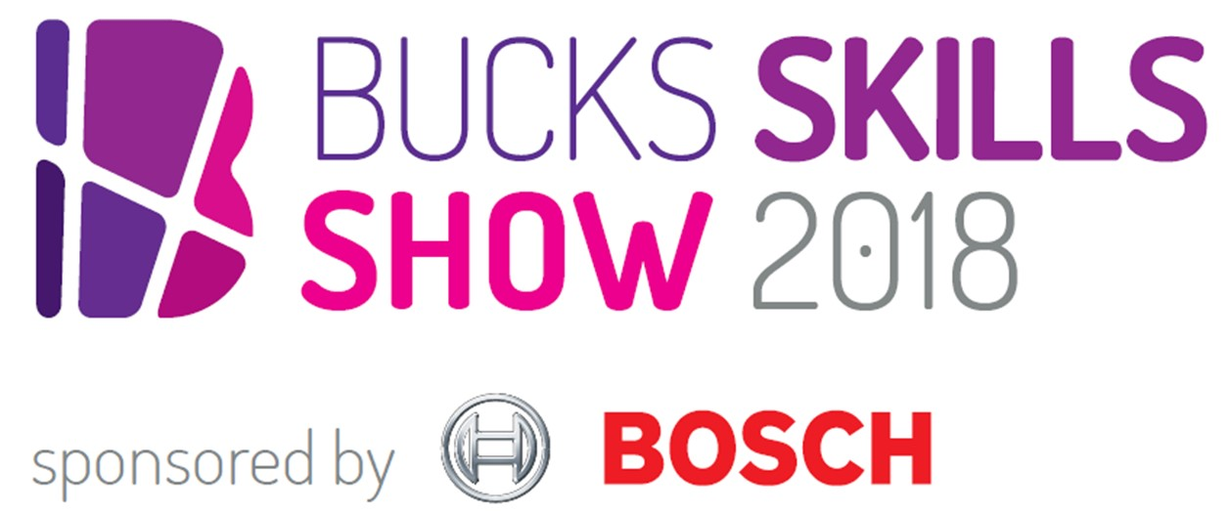
Industry A-listers reveal careers tips at Bucks Skills Show

An A-list cast of speakers from Google to the Ministry of Sound will be headlining the county’s largest interactive careers fair on Saturday 13 October at The Gateway in Aylesbury.

Organisers of the Bucks Skills Show 2018 announced the full line-up today (Monday 10 September), which also includes Cabinet Office Minister and MP for Aylesbury David Lidington, ITV News and Sir Anthony Seldon OBE.

Tech giant Bosch, sponsor of the Bucks Skills Show 2018, is sending Application Engineer Stephanie Alexander to highlight potential careers in science, technology, engineering and maths – known widely as ‘STEM’. Stephanie explained: “STEM is a wide ranging field involving different inventions that make our lives easier. From cars to planes to artificial intelligence, the skills required for a career in STEM are now so much more diverse as we all strive to achieve the same goal in so many different ways. By supporting the Bucks Skills Show, Bosch aims to help young people reveal their potential capabilities, develop their skills and fuel their imaginations.”

more…

Industry A-listers reveal careers tips at Bucks Skills Show: 2

The Rt Hon David Lidington MP, MP for Aylesbury and Minister the Cabinet Office, launches the event with a look at the opportunities for young people created through the Government’s Skills Policy and Industrial Strategy.

Alison Lomax, Director of Lifestyle Retail at Google, will be giving insider tips on careers in digital: "I’m looking forward sharing my career journey with students at the Bucks Skills Show and giving them insights into the plethora of types of digital careers, from YouTube creators to cyber security."

Reshma Rumsey, Social Affairs Producer for ITV News, discusses careers in TV journalism: “I’ve been a journalist for 20 years and have seen the profession evolve and grow. It’s a hugely rewarding career: exciting, unpredictable and has infinite possibilities. But being a journalist is not just about having the talent, you also need to be tough and tenacious. I’m looking forward to meeting the young people attending this great event and possible journalists of the future, and showing them why being a journalist is the greatest job in the world.”

Young people wanting to break into the music industry can head for Ministry of Sound Chairman Lohan Presencer: “The music and entertainment industries have transformed beyond recognition since I started my career. There are now thousands of careers paths which did not exist when I was a student. The challenge is to help the next generation prepare for opportunities which may not yet exist but could be perfectly suited to their skills as digital natives.”

Sir Anthony Seldon OBE, one of the country's most authoritative high profile commentators on contemporary history and education and Vice Chancellor of University of Buckingham, will be closing the event by investigating the impact of artificial intelligence on education and jobs.

more…

Industry A-listers reveal careers tips at Bucks Skills Show: 3

Organised by Buckinghamshire Skills Hub, part of Buckinghamshire Thames Valley Local Enterprise Partnership, the county-wide careers event opens young people’s eyes to the many different job opportunities available, letting them meet employers face-to-face, experience the many activities on offer and be motivated by high profile guest speakers.

The Bucks Skills Show hosts employers from a range of industry sectors: public services; life sciences, health and social care; business; engineering, technology and manufacturing; media and creative; retail, hospitality and leisure. Students can also meet education providers at the ‘Next steps’ area.

Visit Eventbrite.co.uk to book free tickets and for a full line-up of the speakers presenting on Saturday 13 October at The Gateway, Aylesbury, from 9.30am to 3pm. Follow @BucksSkillsShow on Twitter for updates.

Ends

Photo caption: Cyber security firm McAfee are one of the many high profile employers returning to the Bucks Skills Show on Saturday
13 October.

Note to editors
The aim of BTVLEP’s Skills Hub – one of the first LEPs to develop such a hub – is to make a difference to young people’s employability while addressing the needs of employers. In Bucks, the level of employer engagement activity in schools can vary from school to school, and the Buckinghamshire Skills Hub is working to ensure all schools have access to effective and impactful employer interactions.

In order to help young people gain the valuable, constructive, rewarding work experience required, the Bucks Skills Hub has launched WANNABE (www.wannabebucks.org) where employers can post opportunities for young people to apply for. The site provides extensive information, guidance, a careerometer tool to explore earning potential and career prospects, as well as work experience, apprenticeship and part/full time job vacancies. Young people can look for work experience opportunities which are in line with their ambitions, rather than perhaps spending time at their parents’ place of work or finding placements via their parents’ network. There is a broad range of opportunities for young people to apply for.

The Buckinghamshire Thames Valley Local Enterprise Partnership (BTVLEP) is a business-led ‘partnership of equals’ between local government and the private sector, building the conditions for sustainable economic growth in the County. Formed in January 2012, the partnership balances a uniquely strong collective business voice with a cohesive elected local leadership. Coming together to engineer the conditions needed to drive forward business prosperity in the county and beyond, BTVLEP recognises that an important part of this is to support education and skills providers and employers to ensure our young people have the right skills to meet the needs of the economy, including the growth sectors such as life-sciences, space, creative industries and advanced engineering.

Buckinghamshire Business First (BBF), is the Growth Hub for Buckinghamshire and is backed by Buckinghamshire based entrepreneurs, thousands of SMEs and Local Authorities. BBF provides the link between public policy and the business community in Buckinghamshire and works with partners to create a dynamic business environment in the Entrepreneurial Heart of Britain.

For further information please contact:
Richard Burton
Communications Manager

T: 01494 568933
M: 07866 492292
E: richard.burton@btvlep.co.uk

